
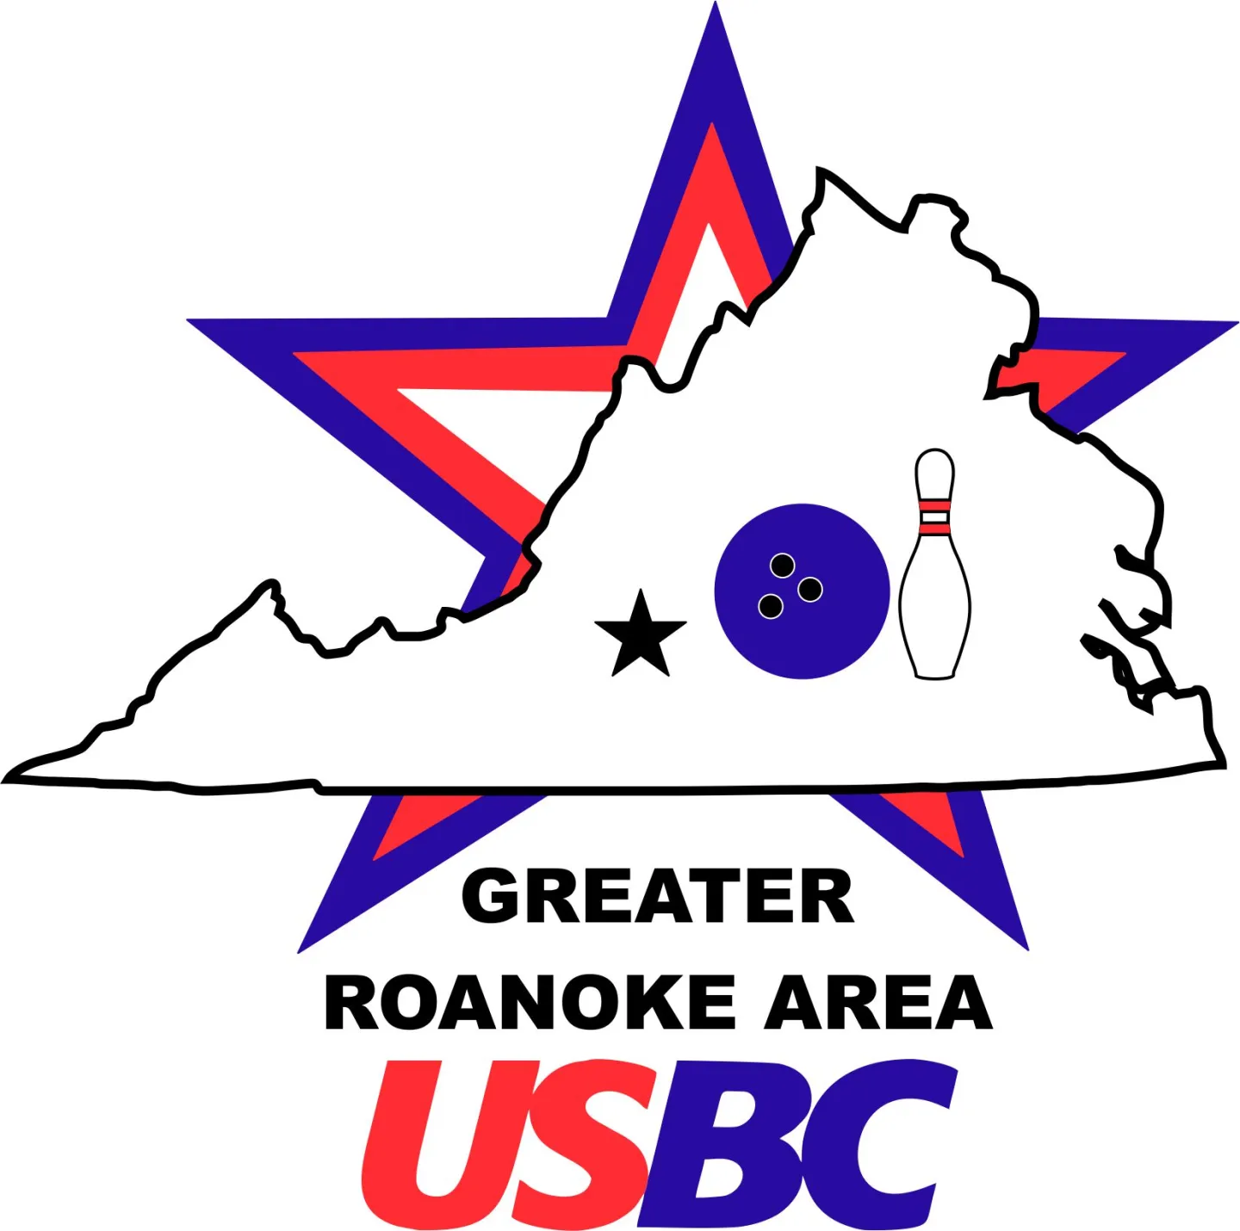
1st Annual GRAUSBC Seniors Tournament
Hosted by:
AMF Hilltop Lanes – Doubles (4 games) event only
**Optional singles event (no added games)

Dates and Times:
October 17th, 2026 @ 10:00 AM or October 18th, 2026 @ 10:00 AM
**Early Entry Deadline October 9th, 2026:

$35.00 per person ($20.00 lineage $15.00 prize fund)
$10 side events (Optional)

All entries received after October 9th , 2026, and walk-in entries are $40 per person for main event; All walk-ins must be present by 11:30 am
Events available
- Hdcp Dbls (required)
- Scratch Dbls (optional)
- Hdcp Singles (optional—will use main event dbls scores)
- Scratch Singles (optional— will use main event dbls scores)

Individual brackets will be available at $6 per person per bracket.

(Preferred) Entries along with full payment can be hand delivered to:
Tanya Young @ Rocky Mount Bowling Center
Jason Pauley or Michael Shafer @ Lee Hi Lanes
Michael Shafer or Kathy Alachnowicz @ Hilltop Lanes
Kathy Alachnowicz to pick up @ Vinton Bowling Ctr

Mailed entries, along with full payment, must be postmarked by October 2nd, 2026, to:
GRAUSBC
ATTN: Kathy Alachnowicz
P.O. Box 7461
Roanoke, VA 24019

Team Captains Name: Phone #__________________
Team Name: ____________________________________________________
DATE PREFERRED: __________________________________________________

Dbls Event  AMF Hill Top Bowling Center  10/17/26 or 10/18/26—Please note that this will be a 4 game tournament | USBC ID # | 2026 Book Average—10 pin rule in effect—please see average section in tournament rules | Dbls Handicap  $70 ($35 per person) by 10/9/26  $80 ($40 per person) after 10/9/26 | Dbls Scratch  $20 per team ($10 per person)
1.
2.

Optional Events  AMF Hill Top Bowling Center  10/17/26 or 10/18/26 | USBC ID # | 2026 Book Average—10 pin rule in effect—please see average section in tournament rules |  | Singles Hdcp -$10 per person (no additional games—will use main event dbls scores) | Singles Scratch-$10 per person (no additional games—will use main event dbls scores)
1.
2.
ENTRY TOTAL$________________________
Tournament Rules
- ****AVERAGE: All bowlers will use their highest 2025-26 Winter adult sanctioned average (21 game min). 10 Pin rule is in effect. If bowler should have a current average as of 10/9/26 that is 10+ pins higher than their yearbook average, they must report and use that average. Bowler must bring verification of this average (league standing sheet will suffice). Failure to report a higher average could constitute disqualification. If a bowler cannot establish a valid average, then they will bowl scratch. Tournament Directors reserve the right to re-rate any tournament bowler.
- USBC Tournament Rules will govern. To qualify as a participant, all bowlers must be a member of the Greater Roanoke Area USBC (GRAUSBC). Unattached members may enter under the conditions outlined in Rule 300c.
- Dbls event is 2 bowlers (any gender) and is a required entry. This tournament will be 4 games. There will be an optional singles event. Singles event will use your main event dbls scores to determine places (no additional games will be bowled)
- Entry fees paid by 10/9/26 are $70 per team ($35 per person). Entries received after 10/9/26 are $80 per team ($40 per person). All other additional events are $10 each per person.
- Allowed to enter multiple times but can only cash 1 time with the same team unless team is constructed with 1 different member. Can only cash one time in the optional singles—highest score will be used
- Handicap based on 90% of 230.
- Any late arrivals will take 0’s for any missed frames.
- Protests involving any scores must be made before payment of tournament prizes.
- One (1) place paid for every eight (8) entries in each event.
- Tournament Directors are Jason Pauley and Kathy Alachnowicz. Tournament directors are eligible to bowl in the tournament and will decide any questions not covered by USBC tournament rules.

